This document will walk taxpayers through the process to make a payment online for an audit that has not yet been billed. There is currently no mechanism in place for this; this is a workaround. After the audit payment has been made, the taxpayer must send an email to Audit Processing to have the payment manually applied to the audit.

*Payment Options*

**Electronic Check**

* Electronic Check is a payment type in the WebFile application
* No fee if the taxpayer is paying by electronic check
* Taxpayer enters banking information (routing number / whole bank account Number) for submittal. For security purposes, this information is not stored in Comptroller databases.
* Payments can take 3-4 business days for processing
* Postmark dates are honored once payment settles.
* Taxpayers can set future dates submitting a payment up to 30 days or due date, whichever is first

**Credit Card**

* All Major Credit Cards are accepted (MasterCard, Visa, Discover and American Express)
* There is no option to choose a future settlement date when paying by a Credit Card
* Fees are listed
* If the payment is equal to or less than $100.00 the fee will be $1.
* If the payment is greater than $100.00 the fee will be 2.25% of the amount paid plus a

$0.25 processing fee

* The Credit Card Portal Processing Fee is separate from the state taxes. It offsets the

cost of the credit card transaction and is non-refundable.

**TEXNET**

* **TEXNET will not appear as an option to pay an audit liability that has been billed.**
* TEXNET is a separate payment system that is a mandate for those who pay over $500k in taxes during the State of Texas’ fiscal year (September 1 – August 31)
* Taxpayers have the option of voluntarily signing up for TEXNET, though may be denied by TEXNET
* Taxpayers can only see this option in WebFile if enrolled in TEXNET prior to submittal
* TEXNET ACH Debit payments must be scheduled by 8 p.m. Central Time the business banking day before the due date
* TENXET has two payment Types, ACH Debit and ACT Credit
* ACH Debit works like Electronic Check
* Taxpayers enrolled in TEXNET ACH credit option “Push” the payment from their bank to ours instead of giving us their banking information
* If a taxpayer is set up for ACH Credit the payment postmark date will be the date the Comptroller receives the payment
* Taxpayers can schedule their TEXNET settlement dates up to 30 days in the future
* Taxpayers can delete or modify a TEXNET payment by logging into TEXNET’s site to delete the payment prior to 8 p.m. CDT on the business banking day prior to the settlement date.
* If a taxpayer has missed their TEXNET scheduling deadline they can submit a payment via wire transfer on the due date. They will also need to contact TEXNET to alert them that they will be sending a wire payment, 1-800-531-5441x3-3010.

*How to submit a payment in WebFile*

* Open an Internet browser and navigate to [www.comptroller.texas.gov](http://www.comptroller.texas.gov)
* Scroll down to the white box labeled Business Center and click on the *WebFile eSytems login* logo(shown below)



* Enter login information under *returning user* or click *Sign up* if a first-time user
* Select WebFile pay taxes/fees



* Choose the desired taxpayer number or enter a new taxpayer number
* Select the tax type for which a payment will be made. This will bring up the main menu for the selected tax type
* On the Tax Main Menu, select *Make a Payment Only*

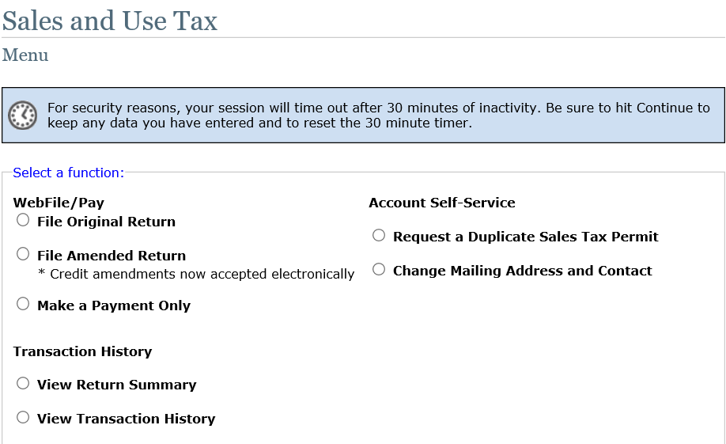

* On the Payment Portal screen, select *Make a Payment,* then select *Continue.*

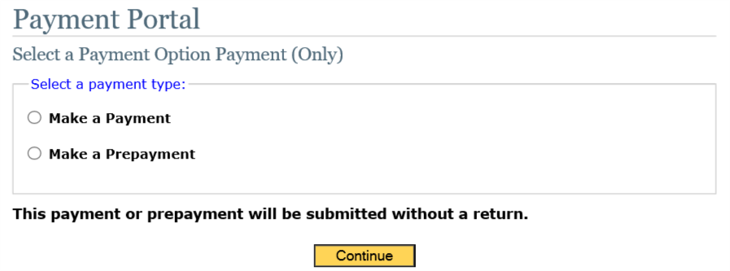

* If the audit has been billed, it will appear as a liability to be paid. Select the audit liability
* If the audit has not been billed, select the next period that has not yet become due. For instance, if the payment will be made between March 21, 2020 and April 20, 2020, select period ending 03/31/2020. If the payment will be made between April 21, 2020 and May 20, 2020, select the period ending 04/30/2020.
* Payment options will display on screen for desired method. Choose *Credit Card* or *Electronic Check*, then select *Continue*. (Note: TEXNET will appear as an option only if it has been previously set up.

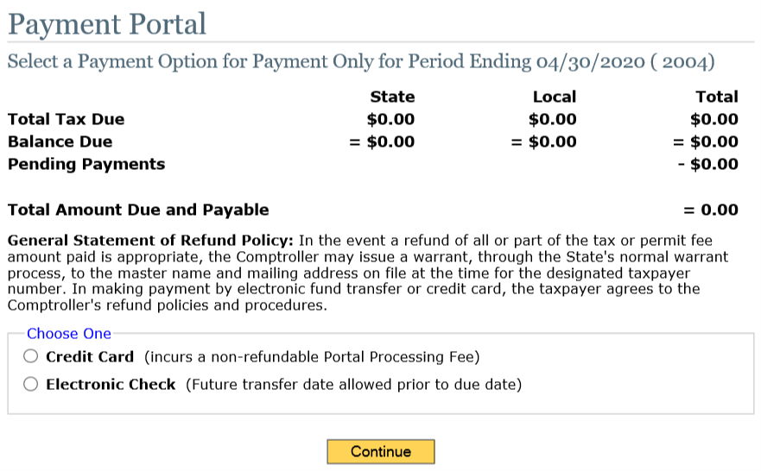

**NOTE: TEXNET will not appear as an option to pay an audit liability that has been billed.**

* Complete the information required for the payment type selected. For credit card payments, the taxpayer will be directed to a third-party processing site for completion of the payment, then directed back to WebFile to display the confirmation page.

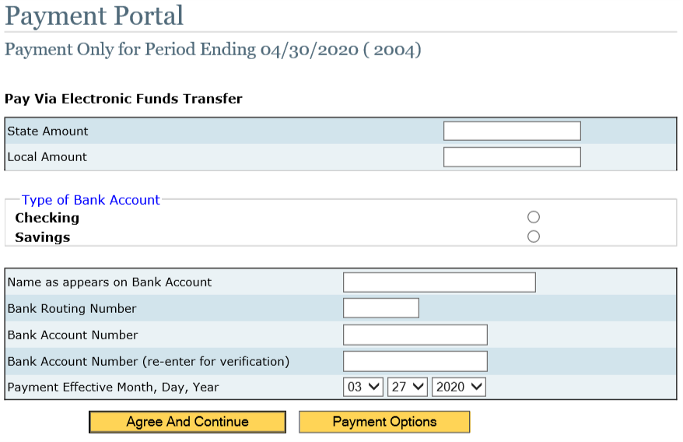

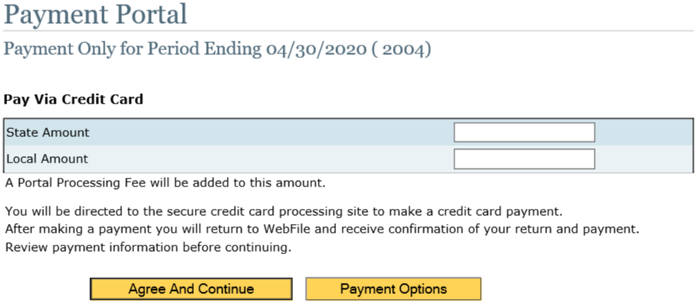

* Once either option is completed, taxpayers receive a confirmation page detailing the transaction and receive a reference number for the submittal
* The reference number is displayed in Transaction History on the tax main menu

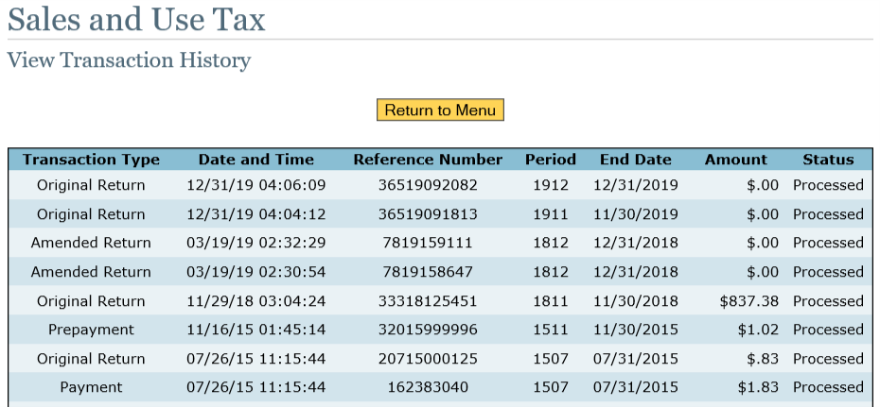

**Please contact Electronic Reporting at (800)-442-3453 (FILE) have any further questions**

*Email Audit Processing to Apply the Payment to the Audit*

* To have the payment applied to the audit, send an email to [audit.processing@cpa.texas.gov](mailto:audit.processing@cpa.texas.gov).
  + In the subject line, include the 11-digit Texas taxpayer number and the phrase “Transfer payment to Audit Period”.
  + In the body of the email include the amount of the payment, the period to which the payment was applied, and the audit period the payment needs to be applied to.
  + Also, include a contact name and phone number in case of questions.
* Once the payment has been applied to the audit, you will receive an email back from Audit Processing confirming the process is complete.